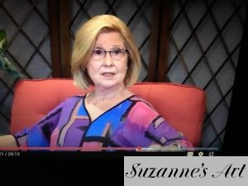
Suzanne Bousquet Foxwell
Author of
The Art of Living a Colorful Life

I have always been attracted to color and have never met one that I didn’t like!
As a young girl, I can remember being transfixed by the ever changing displays of color and shapes during a morning sunrise or an evening sunset. Those flashes of fuchsia, streaked with lemon yellows reds and purples still fascinate me and inspire my work today.
While writing my memoir, I had the opportunity to reflect on how similar my approach to life and art have actually been and how they are reflections of each other. Both are so intertwined and fluid, and I tackle them both in much the same way – “all in”. You might recall your life through art, or create art based on your life experiences. I think everything we do in life is one form of art or another. The way we make people feel welcome, the way we decorate our homes, the way we cook, the way we select our wine, the way we speak, the way we write our names, the outfits we choose, the way we apply make-up or fix our hair, and the way we enter a room full of people – all of these are forms of art.
I thought sharing my story might be helpful to others, because if there is one thing I’ve learned over the years, it’s that if things don’t turn out the way you planned, you can start over in both life and art. It may not be easy, but once you’ve made that first stroke on your blank canvas, each stroke after that will be easier.
“Art, like life, can be a celebration or a catastrophe – depending on your point of view.” –SF

Meet the Author/Artist Event
Sunday, September 9 from 1:00 -3:00 PM

During this time you will have an opportunity to speak with Suzanne about her book The Art of Living a Colorful Life and view some of her original paintings. Her book covers early childhood up to present and is filled with colorful stories and examples of how art and life are reflections of each other.
In the meantime, please visit our meeting room at the back of the store, where you will find a variety of her work on display from August 12-September 9.

